

REPORT ON BOOK MANAGEMENT SYSTEM

WORKING CODE AND IMAGE OF GUI

PROJECT NUMBER: 19

TEAM MEMBERS:

1] NAME : Arul Murugan . B

REG.NO: 12102489

ROLL.NO: RK21KPB66

2] NAME : Tetala Venkata Kumar Reddy

REG.NO: 12108711

ROLL.NO: RK21KPB47

3] NAME : Subhash Desina

REG.NO: 12108755

ROLL.NO: RK21KPB68

CODE:

HOME PAGE:

from tkinter import *

from PIL import Image, ImageTk

root=Tk()

root.geometry('800x600+160+140')

root.title('BOOK MANAGEMENT SYSTEM')

mg=Image.open("D:/Arul murugan/python/x.jpg")

mg1=mg.resize((800,600))

img=ImageTk.PhotoImage(mg1)

xx=Label(image=img)

xx.pack()

def register():

root.destroy()

import register

def signup():

root. destroy()

import signup

Label=Label(root,text="LIBRARY MANAGEMENT SYSTEM",font=('Courier 20'),foreground="red")

Label.pack(side=TOP)

a=Button(root,text="SIGN UP",height= 2, width=9,command=signup)

a.pack()

a.place(x=360, y=210)

b=Button(root,text="REGISTER",height= 2, width=9,command=register)

b.pack()

b.place(x=360, y=290)

SIGN UP PAGE:

import tkinter

from tkinter import *

from tkinter import messagebox as ms

from PIL import Image, ImageTk

import mysql.connector as mc

window=Tk()

window.geometry('800x600+160+140')

mg=Image.open("D:/Arul murugan/python/x2.jpg")

mg1=mg.resize((800,600))

img=ImageTk.PhotoImage(mg1)

xx=Label(image=img)

xx.pack()

window.title('REGISTER')

width=700

height=500

x=60

y=40

window.geometry('800x600+160+140')

def home():

window.destroy()

import home

def signup():

a,b=username.get(),password.get()

mydb = mc.connect(host="localhost",user="root",passwd="1234",database="lib")

c = mydb.cursor()

print(a,b)

if a != '' and b!= '':

# Find the correct user

find_user = (f'SELECT * FROM user WHERE user = %s and password = %s')

c.execute(find_user, [(a), (b)])

result = c.fetchall()

if result:

window.destroy()

import LMS

else:

ms.showerror('Oops!', 'Check the username or password again.')

else:

ms.showerror('Error!', 'Please Enter the details.')

mydb.close()

username=Label(window,text="Username : ",bd=2,font=('Courier 13')).place(x=225,y=170)

username = StringVar()

password=Label(window,text="Password : ",bd=2,font=('Courier 13')).place(x=225,y=230)

password = StringVar()

e1=Entry(window,textvariable=username,width=30).place(x=350,y=170)

e2=Entry(window,textvariable=password,width=30).place(x=350,y=230)

a=Button(window,text="SIGN UP",height= 2, width=15,command=signup)

a.pack()

a.place(x=340,y=290)

b=Button(window,text="HOME",height= 2, width=15, command=home)

b.pack()

b.place(x=30,y=30)

window.mainloop()

REGISTER PAGE:

import tkinter

from tkinter import *

from tkinter import messagebox as ms

from PIL import Image, ImageTk

import mysql.connector as mc

window=Tk()

window.geometry('800x600+160+140')

mg=Image.open("D:/Arul murugan/python/library photo.jpg")

mg1=mg.resize((800,600))

img=ImageTk.PhotoImage(mg1)

xx=Label(image=img)

xx.pack()

window.title('Register')

width=700

height=500

x=60

y=40

window.geometry('800x600+160+140')

def new():

a3,b3,c3,d3,p1=a2.get(),b2.get(),c2.get(),d2.get(),p.get()

mydb = mc.connect(host="localhost",user="root",passwd="1234",database="lib")

c = mydb.cursor()

print(a,b)

if a3 != '' and b3!= '' and c3 != '' and d3!= '' and e3 != '':

# Find the correct user

#print(a3,b3,c3,d3,p3)

find_user = (f"insert into user values(%s,%s,%s,%s,%s);")

c.execute(find_user, [(a3), (b3), (c3), (d3), (p1)])

mydb.commit()

mydb.close()

window.destroy()

else:

ms.showerror('Error!', 'Please Enter the details.')

import signup

def home():

window.destroy()

import home

First_name=Label(window,text="First Name:",bd=2,font=('Courier 13')).place(x=225,y=150)

Last_name=Label(window,text="Last Name:",bd=2,font=('Courier 13')).place(x=235,y=200)

reg_no=Label(window,text="Reg_number:",bd=2,font=('Courier 13')).place(x=225,y=250)

user_id=Label(window,text="user id:",bd=2,font=('Courier 13')).place(x=250,y=300)

passw=Label(window,text="Password:",bd=2,font=('Courier 13')).place(x=240,y=350)

a2,b2,c2,d2,p=StringVar(),StringVar(),StringVar(),StringVar(),StringVar()

e1=Entry(window,textvariable=a2,width=30,bd=3).place(x=350,y=150)

e2=Entry(window,textvariable=b2,width=30,bd=3).place(x=350,y=200)

e3=Entry(window,textvariable=c2,width=30,bd=3).place(x=350,y=250)

e4=Entry(window,textvariable=d2,width=30,bd=3).place(x=350,y=300)

e5=Entry(window,textvariable=p,width=30,bd=3).place(x=350,y=350)

a=Button(window,text="REGISTER",height= 2, width=9,command=new)

b=Button(window,text="HOME",height= 2, width=9,command=home)

a.pack()

a.place(x=350, y=400)

b.pack()

b.place(x=30, y=30)

window.mainloop()

LMS PAGE:

import tkinter

from tkinter import *

from tkinter import messagebox

from PIL import Image, ImageTk

window=Tk()

window.geometry('800x600+160+140')

mg=Image.open("D:/Arul murugan/python/org image.jpg")

mg1=mg.resize((800,600))

img=ImageTk.PhotoImage(mg1)

xx=Label(image=img)

xx.pack()

window.title('LMS')

width=700

height=500

x=60

y=40

window.geometry('800x600+160+140')

def home():

window.destroy()

import home

def back():

window.destroy()

import signup

def avail():

window.destroy()

import availablebooks

def issue():

window.destroy()

import issuebooks

def returnbooks():

window.destroy()

import returnbooks

a=Button(window,text="HOME",height= 2, width=9,command=home)

a.pack()

a.place(x=30, y=30)

b=Button(window,text="BACK",height= 2, width=9,command=back)

b.pack()

b.place(x=130, y=30)

c=Button(window,text="AVAILABLE BOOKS",height= 3, width=20,bd=3,command=avail)

c.pack()

c.place(x=340,y=200)

d=Button(window,text="RETURN BOOK",height= 3, width=20,bd=3,command=returnbooks)

d.pack()

d.place(x=340,y=280)

e=Button(window,text="ISSUE BOOK",height= 3, width=20,bd=3,command=issue)

e.pack()

e.place(x=340,y=360)

window.mainloop()

AVAILABILITY PAGE:

import tkinter

from tkinter import *

from tkinter import messagebox

from PIL import Image, ImageTk

from tkinter import ttk

import mysql.connector as mc

win=Tk()

win.title(‘AVAILABILITY’)

win.geometry('800x600+160+140')

style = ttk.Style()

style.theme_use('clam')

mydb = mc.connect(host="localhost",user="root",password="1234",database="lib")

c = mydb.cursor()

c.execute("select * from ab where reg_no is NULL;")

lst=[i for i in c]

print(lst)

mydb.close()

tree = ttk.Treeview(win, column=( " book_id","book_name","author"), show='headings', height=5)

tree.column("# 1", width=100,anchor=CENTER)

tree.heading("# 1", text="book_id")

tree.column("# 2", anchor=CENTER)

tree.heading("# 2", text="book_name ")

tree.column("# 3", anchor=CENTER)

tree.heading("# 3", text="author")

for i in range(len(lst)):

tree.insert('', 'end', text="1", values=lst[i])

tree.pack()

win.mainloop()

ISSUE BOOK PAGE:

from tkinter import *

from PIL import Image, ImageTk

from tkinter import messagebox as ms

import mysql.connector as mc

import time

root=Tk()

root.title('issue book')

root.geometry('800x600+160+140')

mg=Image.open("D:/Arul murugan/python/org image.jpg")

mg1=mg.resize((800,600))

img=ImageTk.PhotoImage(mg1)

xx=Label(image=img)

xx.pack()

def home():

root.destroy()

import home

def back():

root.destroy()

import LMS

def new():

root.destroy()

import newpage

def issued_b():

mydb = mc.connect(host="localhost",user="root",password="1234",database="lib")

c = mydb.cursor()

if book_id.get() != '':

a1 = n_reg.get()

b1 = book_id.get()

c.execute(f'SELECT * FROM ab WHERE book_id = "{b1}" ')

if c.fetchall() :

dt=list(time.localtime())[:3]

dt=[str(i) for i in dt]

dt="-".join(dt)

c.execute(f"insert into ss_ret values('{a1}','{b1}','{dt}',NULL,'pending');")

c.execute(f"update ab set reg_no='{a1}' where book_id='{b1}';")

mydb.commit()

ms.showinfo('book issued successfully')

else:

ms.showerror("Error!', 'The book is not available or invalid username.")

else:

ms.showerror('Error!', 'Please Enter the details.')

mydb.close()

a=Button(root,text="HOME",height= 2, width=9,command=home)

a.pack()

a.place(x=30, y=30)

b=Button(root,text="BACK",height= 2, width=9,command=back)

b.pack()

b.place(x=130,y=30)

Book_id=Label(root,text="Book Id:",bd=2,font=('Courier 13')).place(x=225,y=150)

Reg_No=Label(root,text="Reg.No:",bd=2,font=('Courier 13')).place(x=235,y=200)

n_reg = StringVar()

book_id = StringVar()

e1=Entry(root,textvariable=n_reg,width=30,bd=3).place(x=350,y=150)

e2=Entry(root,textvariable=book_id,width=30,bd=3).place(x=350,y=200)

a=Button(root,text="ISSUE",height= 2, width=9,command=issued_b)

a.pack()

a.place(x=350, y=400)

root.mainloop()

RETURN BOOK PAGE:

from tkinter import *

from PIL import Image, ImageTk

import time

import mysql.connector as mc

from tkinter import messagebox as ms

root=Tk()

root.title('return book')

root.geometry('800x600+160+140')

mg=Image.open("D:/Arul murugan/python/org image.jpg")

mg1=mg.resize((800,600))

img=ImageTk.PhotoImage(mg1)

xx=Label(image=img)

xx.pack()

def home():

root.destroy()

import home

def back():

root.destroy()

import LMS

def new():

root.destroy()

import newpage

def return_b():

mydb = mc.connect(host="localhost",user="root",password="1234",database="lib")

c = mydb.cursor()

if book_id.get() != '' and n_reg.get()!= '':

a1 = n_reg.get()

b1 = book_id.get()

c.execute(f'SELECT * FROM ab WHERE book_id = "{b1}" ')

if c.fetchall() :

dt=list(time.localtime())[:3]

dt=[str(i) for i in dt]

dt="-".join(dt)

c.execute(f"update ss_ret set return_date='{dt}' where book_id='{b1}';")

c.execute(f"update ss_ret set status='returned' where book_id='{b1}';")

c.execute(f"update ab set reg_no=NULL where book_id='{b1}';")

mydb.commit()

ms.showinfo('book issued successfully')

else:

ms.showerror("Error!','The book is not available or invalid username.")

else:

ms.showerror('Error!','Please Enter the details.')

mydb.close()

a=Button(root,text="HOME",height= 2, width=9,command=home)

a.pack()

a.place(x=30, y=30)

b=Button(root,text="BACK",height= 2, width=9,command=back)

b.pack()

b.place(x=130,y=30)

Book_id=Label(root,text="Book Id:",bd=2,font=('Courier 13')).place(x=225,y=150)

Reg_No=Label(root,text="Reg.No:",bd=2,font=('Courier 13')).place(x=235,y=200)

n_reg = StringVar()

book_id = StringVar()

e1=Entry(root,textvariable=n_reg,width=30,bd=3).place(x=350,y=150)

e2=Entry(root,textvariable=book_id,width=30,bd=3).place(x=350,y=200)

a=Button(root,text="RETURN",height= 2, width=9,command=return_b)

a.pack()

a.place(x=350, y=400)

root.mainloop()

GUI IMAGES OF PROJECT:

HOME PAGE:

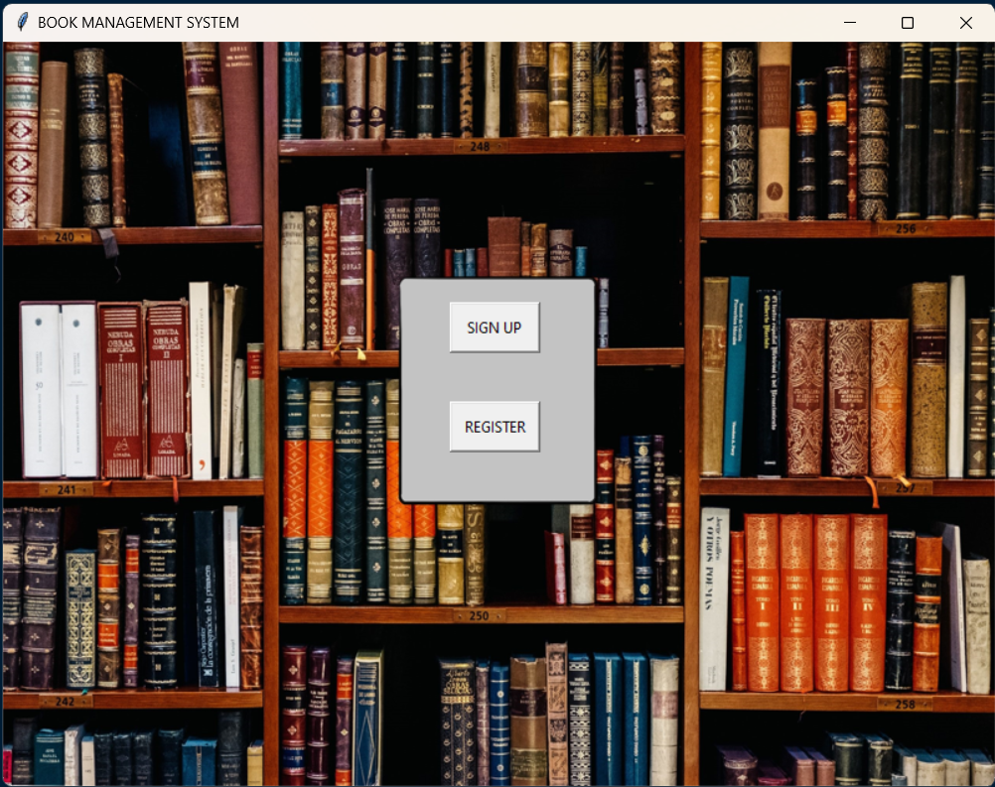

SIGN UP PAGE:

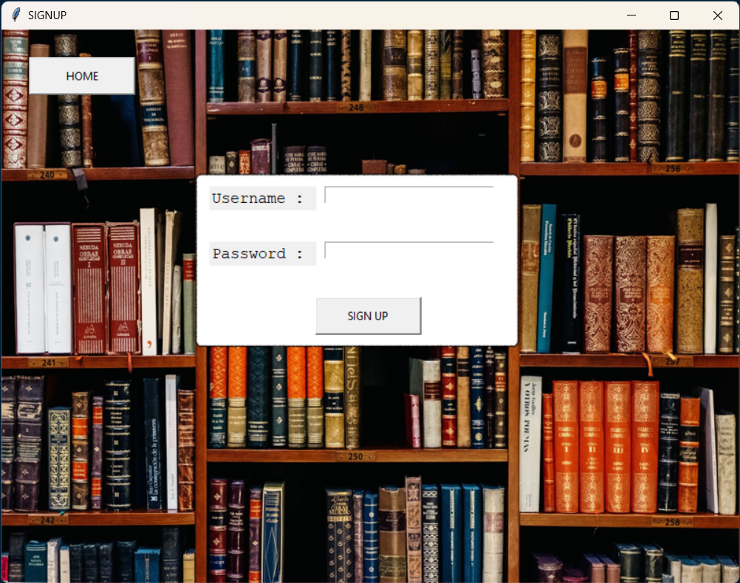

REGISTER PAGE:

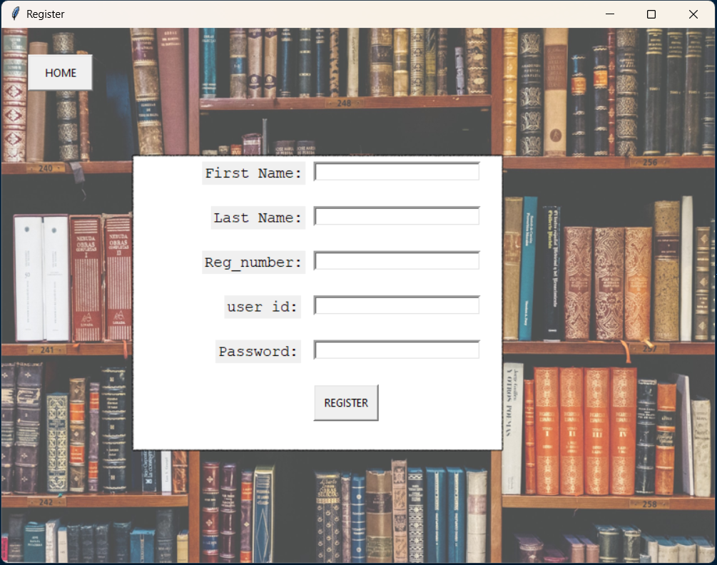

LMS PAGE:

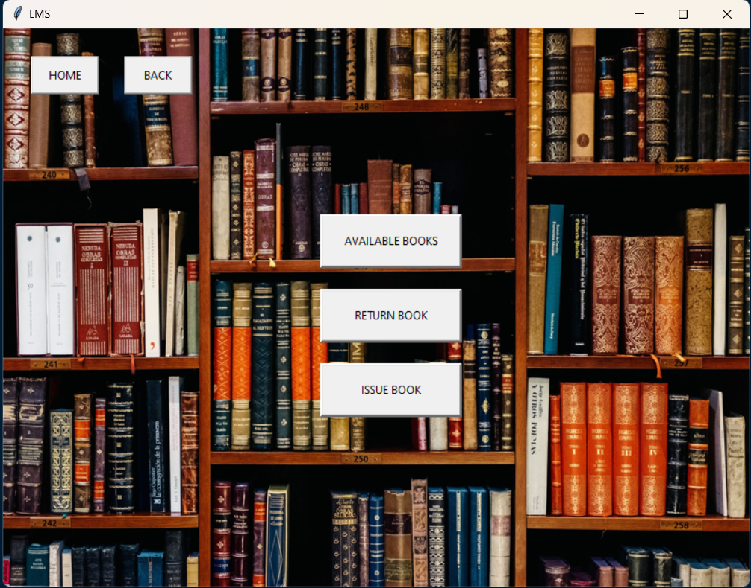

AVAILABLE BOOKS PAGE:

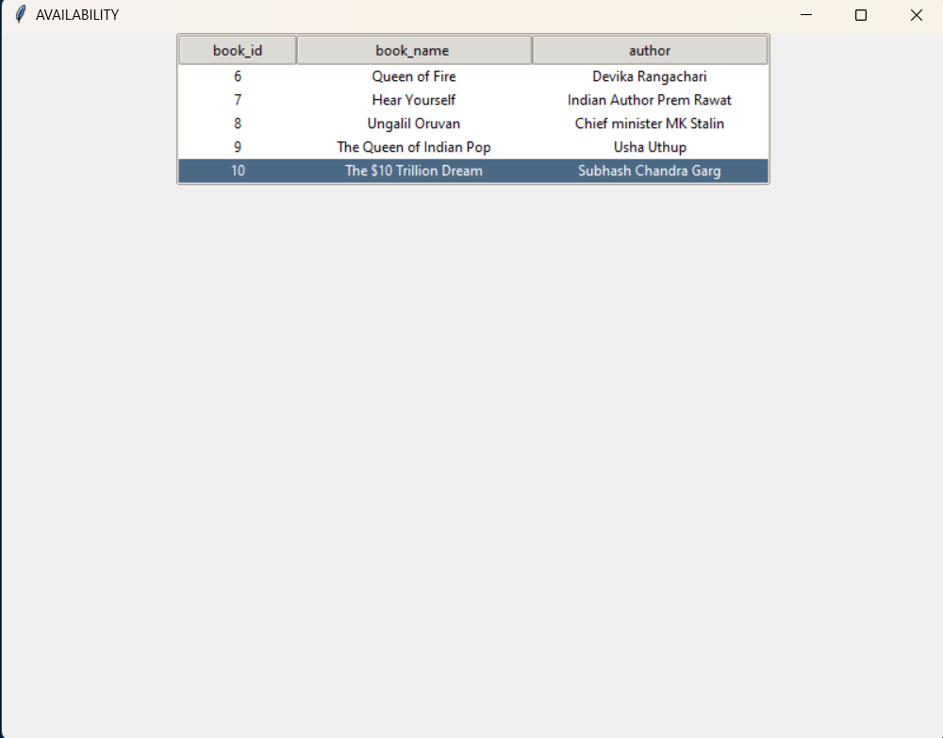

ISSUE BOOKS PAGE:

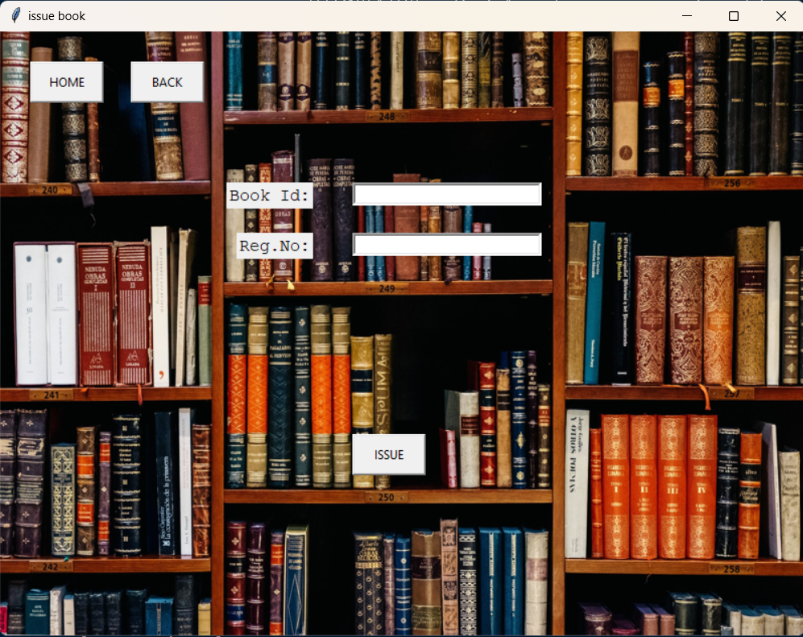

RETURN BOOKS PAGE:

